I want to develop for Tarot Product:

**a)  APP (Android).**

You can see a similar App to inspirate in it:

<https://play.google.com/store/apps/details?id=com.grupoprecedo.tarotgratis&hl=en>

Make the same functionality, when your APP have the same functionallity, you’ll send us the next content to make original ones:

1. **All image files** you need and we’ll make another ones with the same speification and filenames.
2. **A XML file** or another files with all text/names for content you need and we’ll change and translate it to English and Spanish versión.

**Applications (Android) specifications:**

* Android for Tarot. (Multilanguage. (ES /EN))
* This application will include some games around Tarot, new APP must include similar functions to:

1. <https://play.google.com/store/apps/details?id=com.grupoprecedo.tarotgratis&hl=en>

All Functions **except (NOT will be included):**

* **Tarot Osho Zen**
* **APP Horoscope Gratis**
* **APP Oracule**

**NOTES:**

The most important effort in this APP is to implement the cards’s moving to make real.

1. **Advertisement Google Adsense:** APP will include advertisement like the APP:

<https://play.google.com/store/apps/details?id=com.grupoprecedo.tarotgratis&hl=en>

1. Firebase: App will be include Firebase to send APP Notifications from Google FireBase panel.
2. **Numbers to call:** At the end of each game, include a “Call Service”. I need to estably an XML for configuration depends on Country.

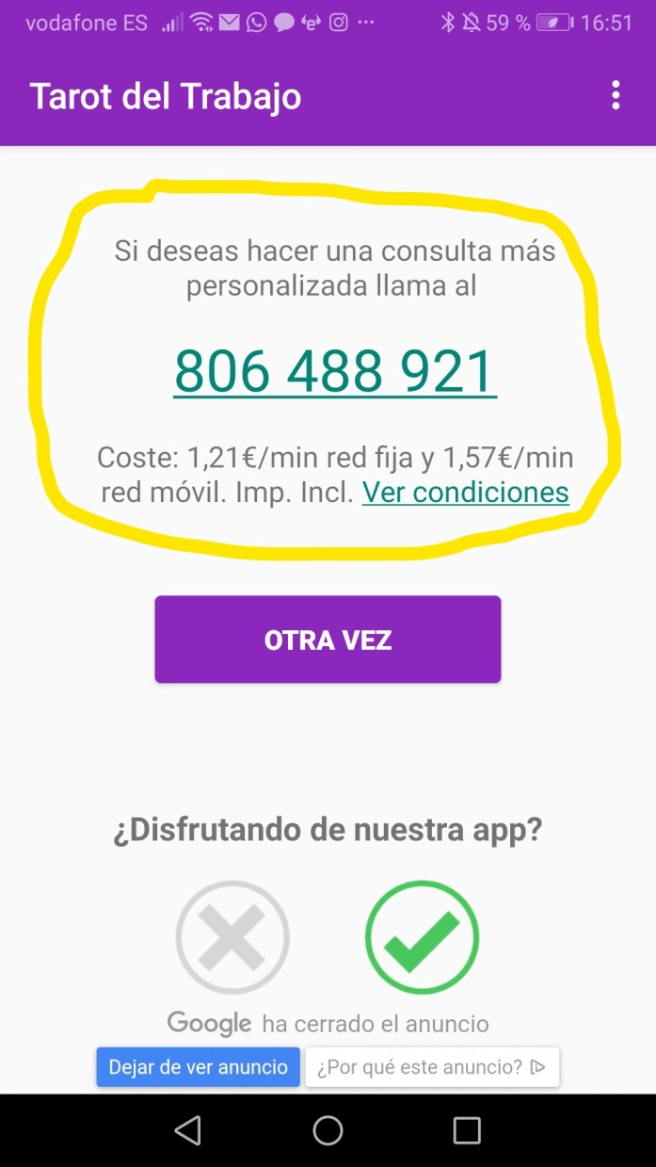

For example: For Spain: Phone: 806421512

For Argentina: Phone: 009162937286

1. **Contents update:** You have an XML specification contents File for Country. You’ll compile with an specific file XML file contents, but each time user’ll start the APP you request the last file to an specific URL for update the contents if it’ll be necessary.

